­­­­

Problem Statement-1: How It Works

Table of Content



JAVA SPRING BOOT-I

4

5

**THANK YOU**

1

3

**PROJECT EXECUTION SCREENS**

**PROJECT EXECUTION**

**PREREQUISIITE**

**PROJECT STRUCTURE**

2

**Prerequisite**

1. Latest and stable version of Spring Tool Suite or Eclipse should be installed
2. Java should be installed
3. Maven should be installed
4. MySQL Workbench should be installed

**Project Structure**

**UI**

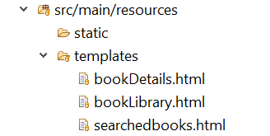

**API**

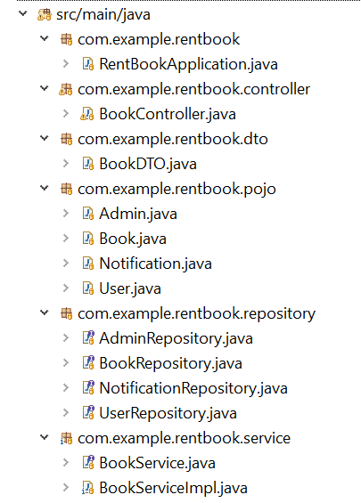

**Database**

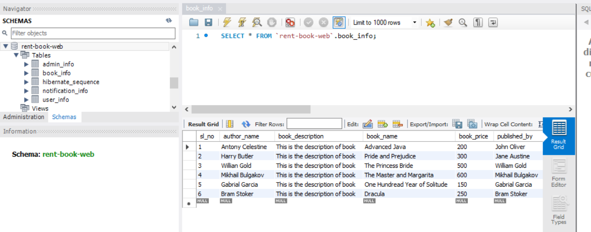

**Project Execution**

1. Import the project to IDE
2. Update the Maven Dependency
3. Import the database
4. Run the project as spring boot application

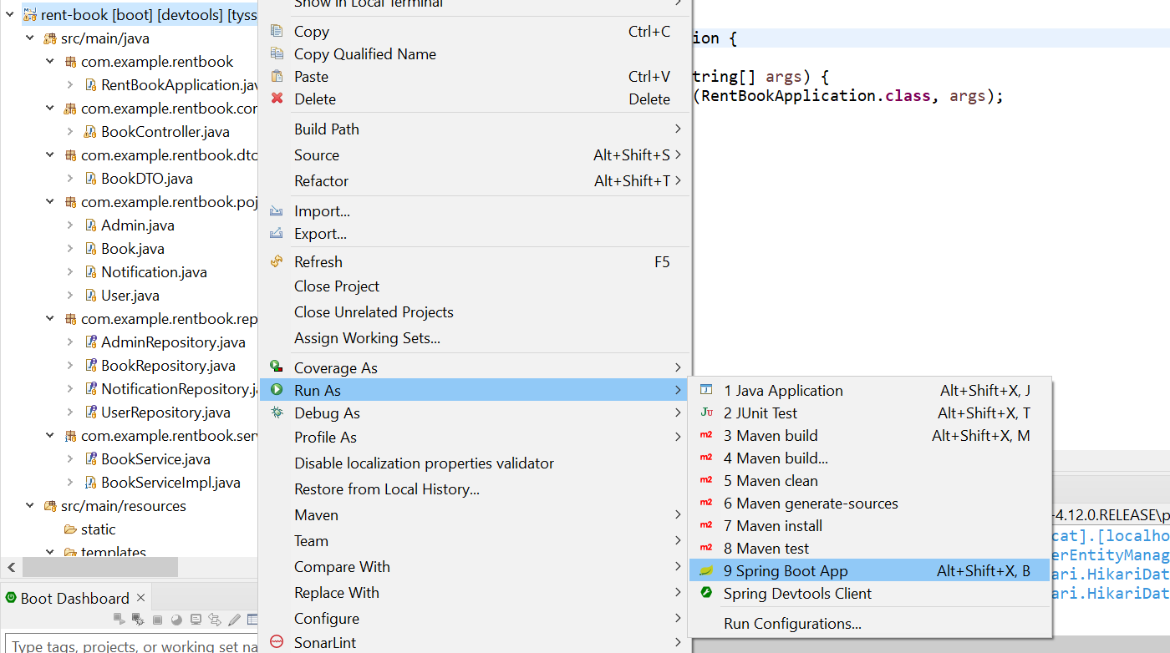

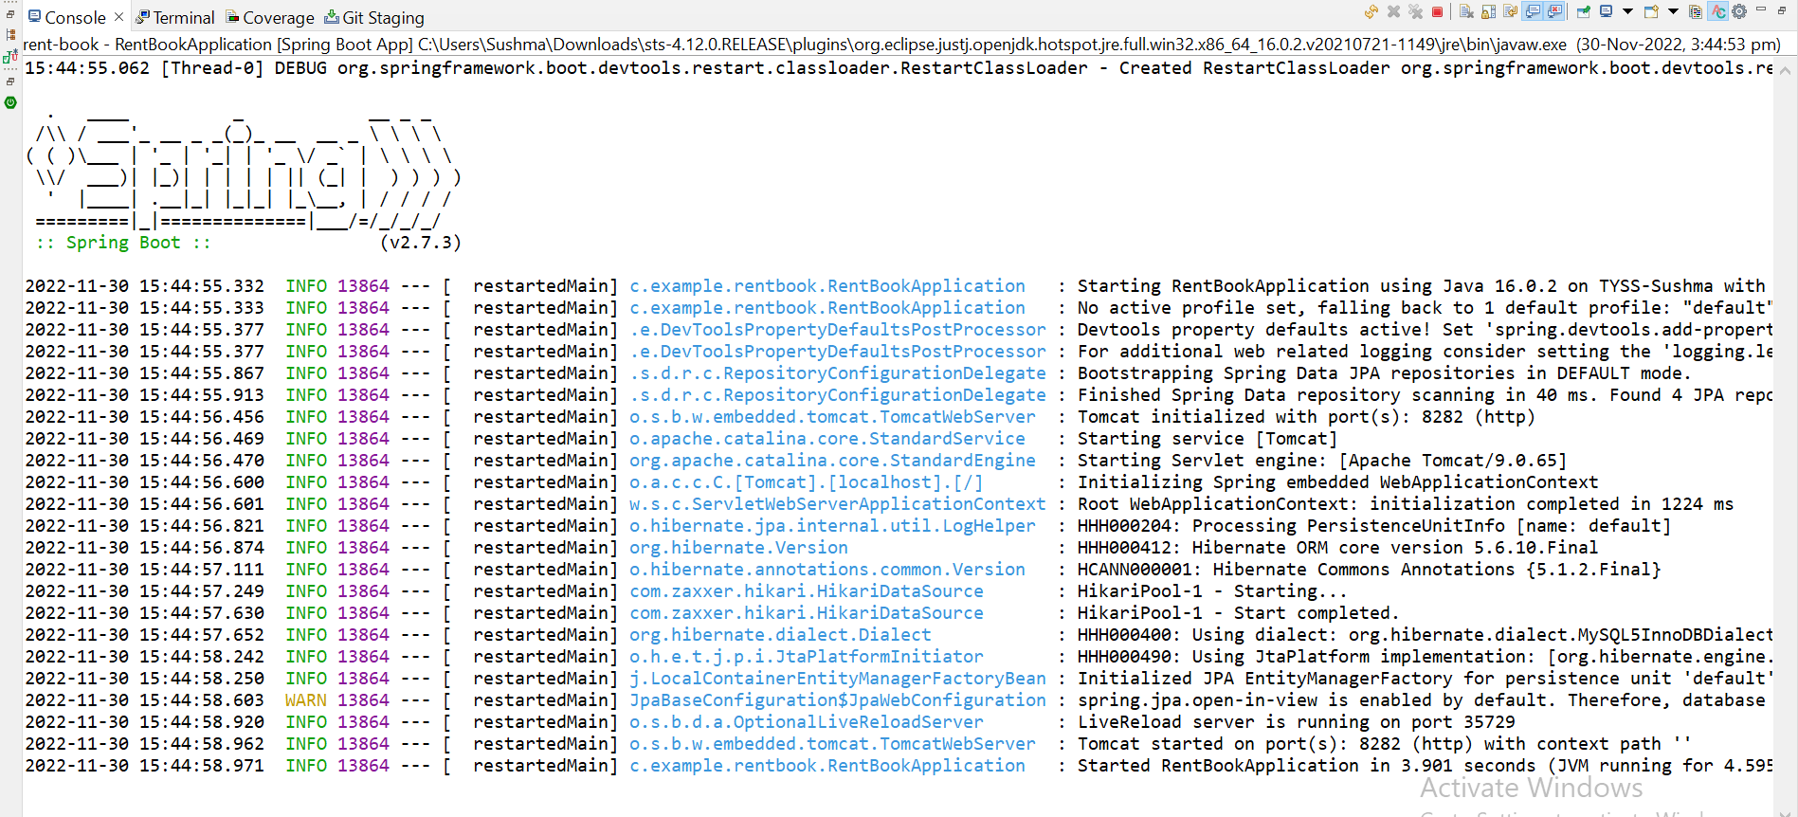

Open browser with Project URL: **http://localhost:8282**

**Project Execution Screens**

**1.** Home Page, Welcome message will be displayed

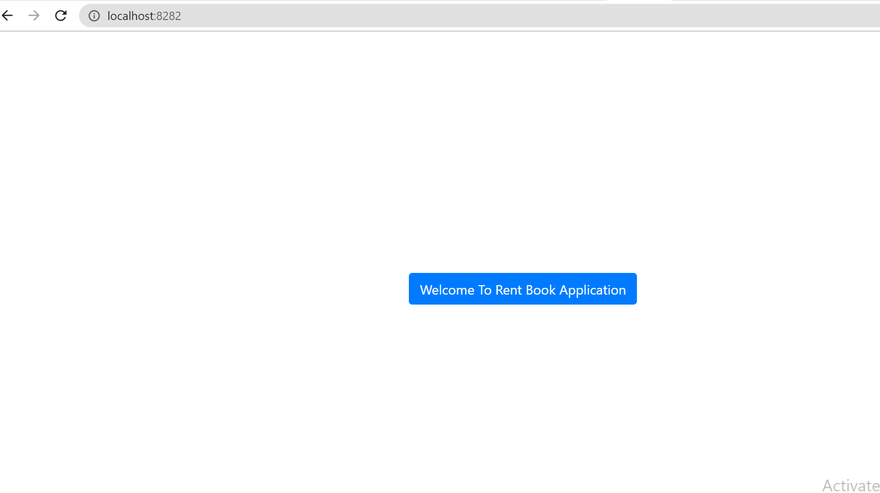

On click of “Welcome To Rent Book Application” button, all the books will

be displayed

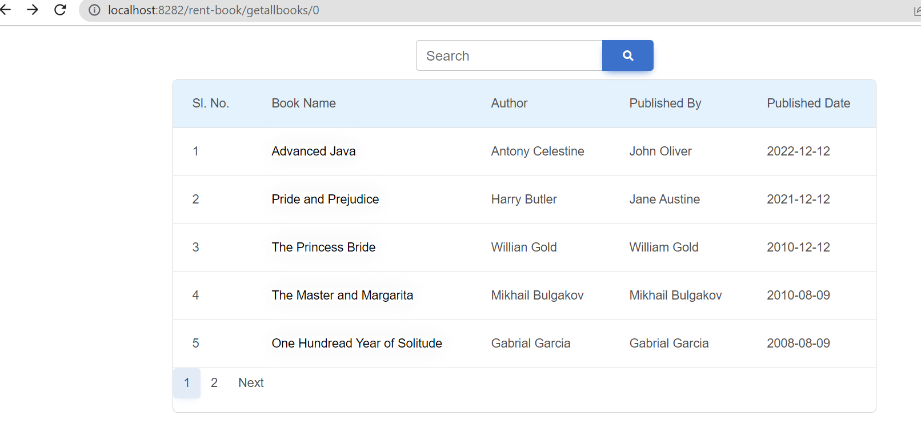

**2.** Search Functionality – User can search a book by its name or author’s name

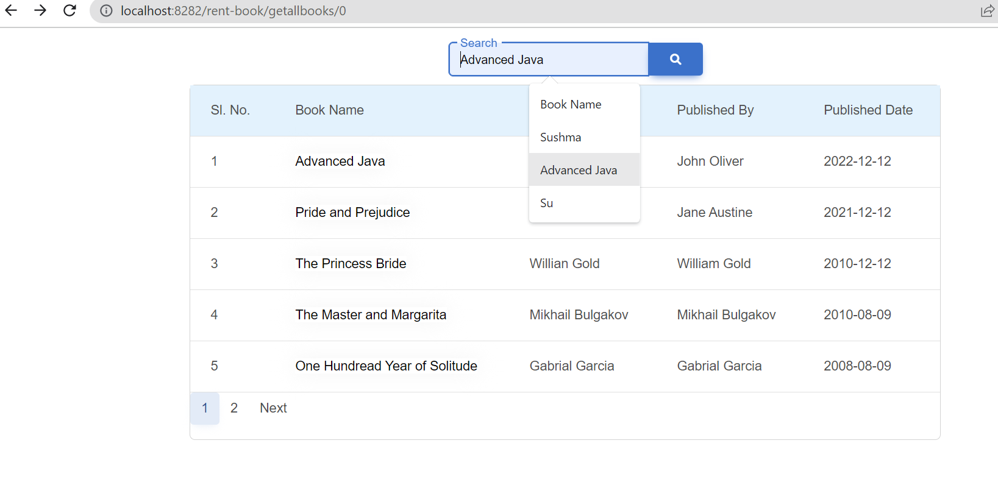

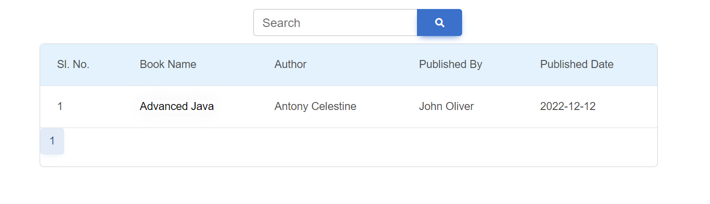

**2**. After clicking on Book Name, complete book details will be displayed

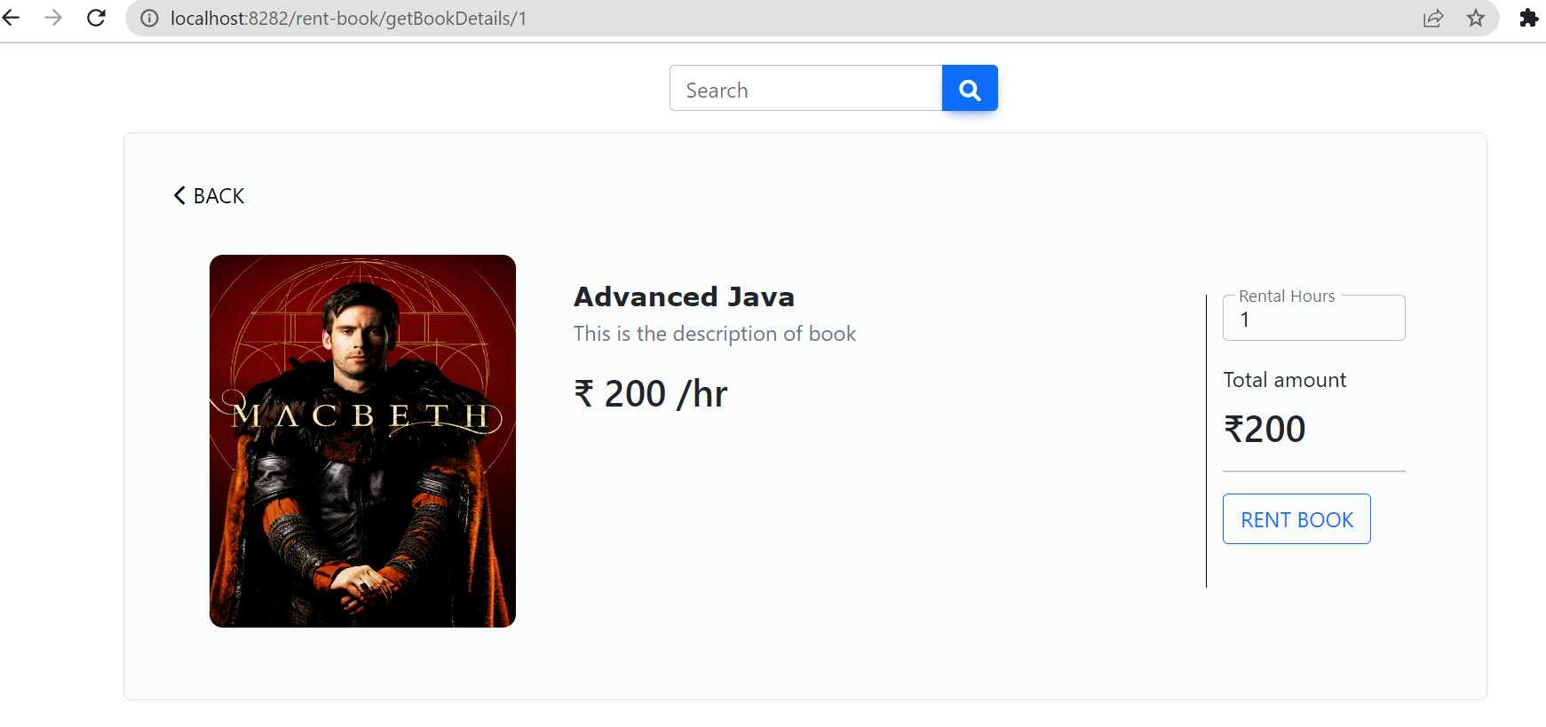

3. User can give rental hours, based on which total amount will be calculated.

After clicking on Rent Book, specified amount will be credited to admin and notification

will be sent to both admin and user and success message will be displayed.

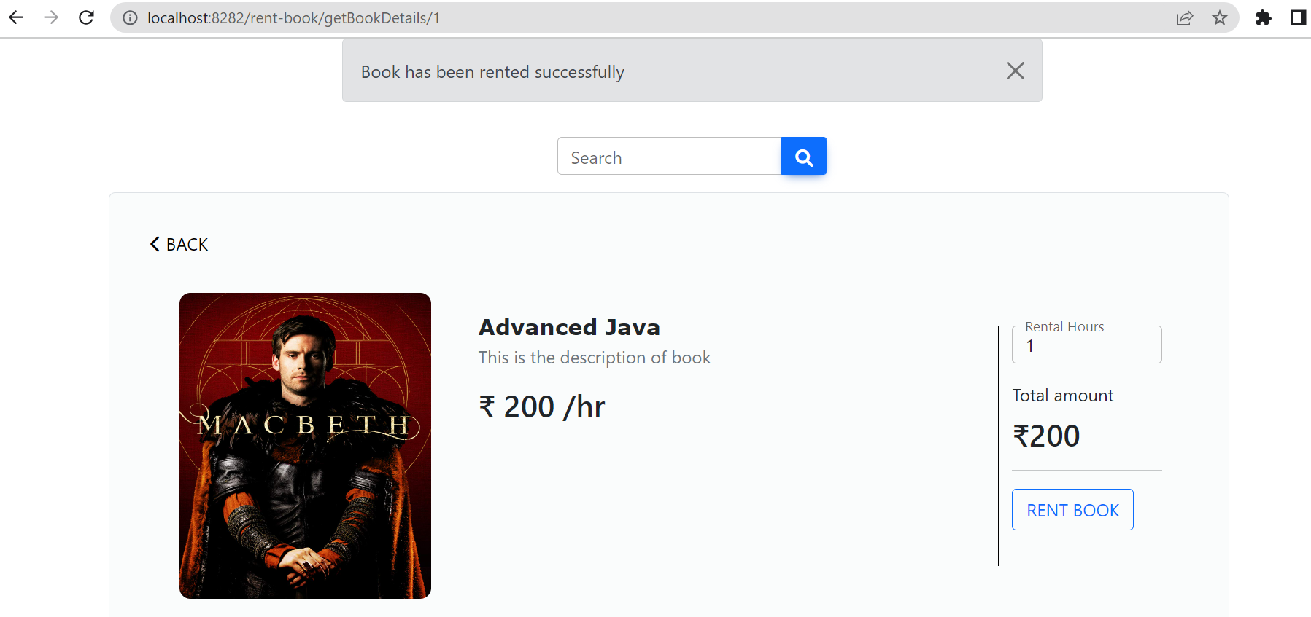

**4**. Database: Before renting the book, data in Notification and Admin Table.

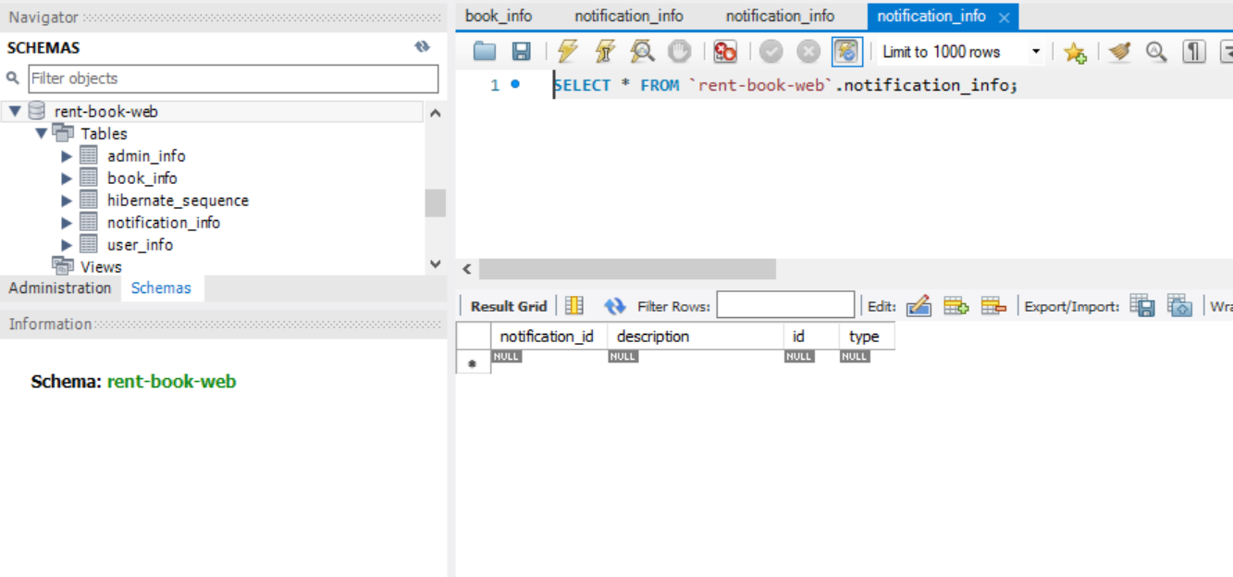

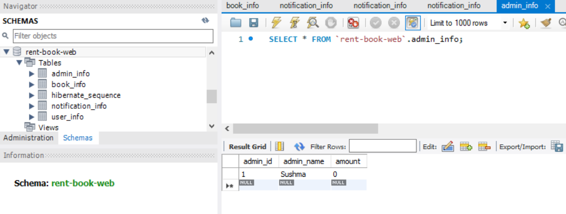

After renting the book, data in Notification and Admin Table.

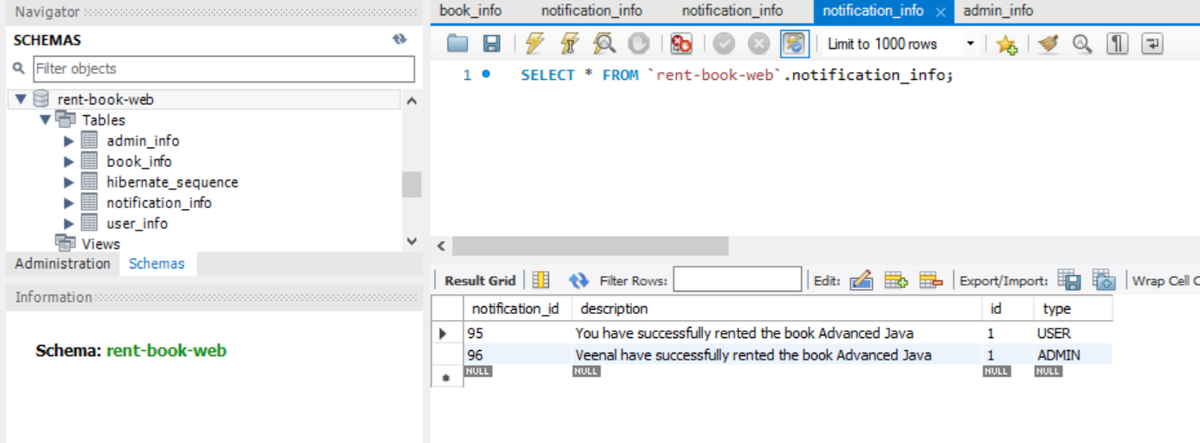

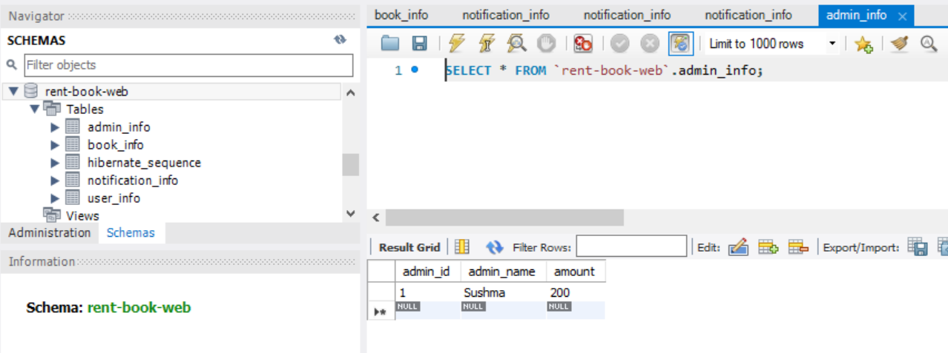

**Thank You**